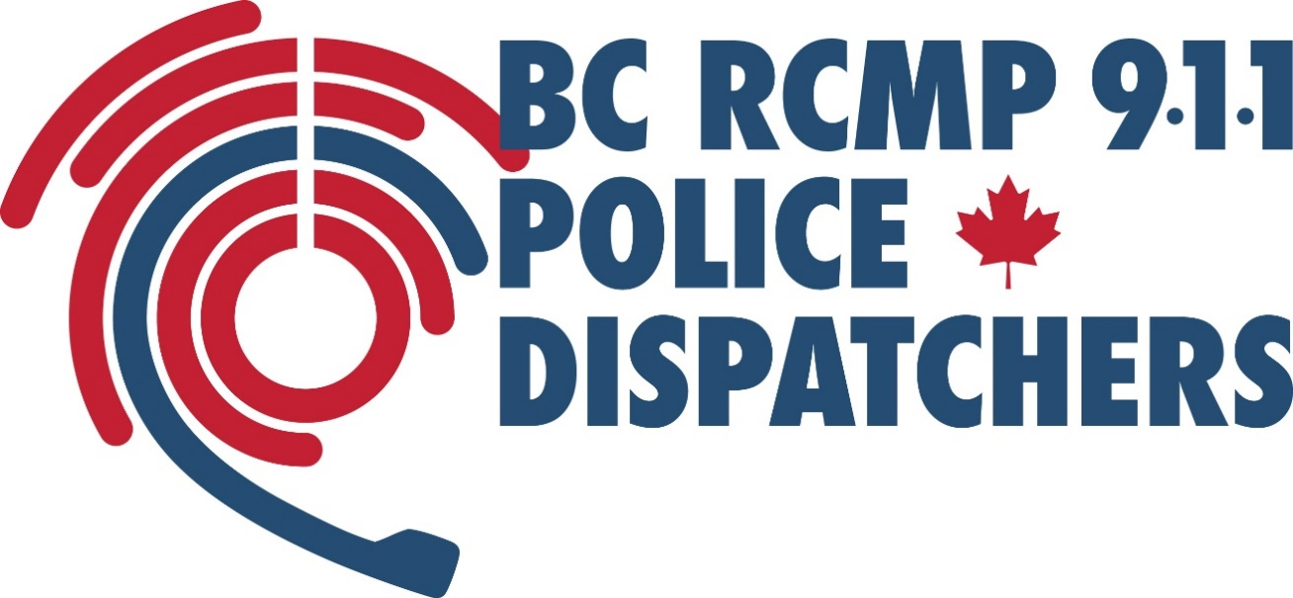

BC RCMP Student Police Call Taker Program

Location: Surrey, BC
Contract: Fulltime shift work from May to September 2024
Rate of Pay: $32.84 / hour

BC RCMP offers a unique job experience for college and university students to work in a police environment and work alongside 9-1-1 Police Dispatchers in a dynamic workplace.

Choosing to participate in the Student Police Call Taker Program may be one of the most rewarding decisions you will make. The position offers many opportunities to make a positive difference in the lives of others.

Student Police Call Takers are scheduled to work fulltime shift work from May to September. Students receive eight weeks of training before they begin answering non-emergency calls for police assistance. Students are assigned a field coach to support them through the training program.
Who We Are
The BC RCMP 9-1-1 Police Dispatch Centre in Surrey, is a closely connected team of supportive individuals who are passionate about their career and who have a common purpose to help and protect others. We are proud to be part of a caring culture where our co-workers become our second family and our strong teamwork builds a positive work environment.
What We Do
We answer calls from the public who are reporting a crime and need police assistance. We quickly and accurately obtain all the information needed to assist the police in responding to the request for help.
Who We’re Looking For
You have a strong desire to make a difference in the community. The opportunity to help people in need excites and motivates you. You possess a high level of accountability and commitment, and your ability to complete multiple tasks under pressure is reflective of your capacity to be a quick thinker. You are known for your great communication skills and can quickly summarize what you hear. You thrive in a fast pace environment. You are able to demonstrate self-control and composure during high pressure moments.
You have a thirst to learn and seek out opportunities to learn in an interactive environment. You are proficient in using a computer and you have accurate and fast typing skill.
You enjoy job opportunities where every day and every shift is different, no two days are the same. You look forward to engaging with people from all different walks of life and helping them through difficult situations.
Prerequisites
BC RCMP is recruiting students who reside in British Columbia. Only applications from this area of selection will be considered.
To be considered for a Student Police Call Taker position, you must:
- Be a Canadian Citizen.
- Resided (been physically) in Canada for the last 10 years.
- Posses a Canadian high school diploma.
- Be a student registered at a recognized Canadian post-secondary institution.
- Be proficient in English
Application Process
The first step is to attend a Student Career Presentation. This information session offers you the chance to hear first-hand from our Recruiters about the exciting opportunity to work as a Student Police Call Taker in the summer. You will also receive information about the requirements and expectations for the Student Police Call Taker Application Process.
Student Career Presentations are approximately one hour. Visit the Recruiting Events page at bcrcmp911.ca to select a Student Career Presentation event located near you.
Applications for the May 2024 intake are being accepted until October 20, 2023.

